VLDB ANNUAL CONFERENCE

Principles, Policies and Guidelines
VLDB Endowment
October 16, 2012
Based on previous versions 1984, 1988, 1991, 1995, 1997, 1998, 1999

THE CONFERENCE
The series of VLDB Conferences is governed by the VLDB Endowment (referred to as the Endowment in the following), which acts as the steering committee, by awarding individual Conferences and supervising them according to these guidelines.
The official title of the Conference is "Nth International Conference on Very Large Data Bases", and may be abbreviated to " VLDB 20xx", where xx is the year of the conference.
The conference Web site and material should mention the VLDB Endowment (with its logo). The conference Web site should be maintained at http://www.vldb.org/20xx.

CONFERENCE DATE
The conference date should normally fall around September 15, give or take one month. The conference date, proposed by the organizers, has to be agreed upon by the Endowment, and any proposals for changing it should be agreed upon as well.
The conference should make all reasonable efforts to avoid major religious holidays over this period. Two particular Jewish celebrations - Rosh Hashanah and Yom Kippur - occur at varying times in September and should be taken into account when deciding on the conference dates.

CONFERENCE LOCATION
The VLDB Conference is probably the most international, annual event in the database area. The Conference site should rotate among all continents and countries of the world. The Endowment tries to coordinate the choice of continents with the other major database conferences (but this has become more complex recently). Locations should be selected on the basis of the organizers' ability to hold a successful conference of the quality traditional to VLDB, as well as on considerations on the cost and convenience of attending. Moreover, it should be guaranteed that no restrictions are imposed by the host country on participation at the Conference.

CONFERENCE PROPOSALS, SUBMISSION AND DECISION
The VLDB Endowment has the responsibility of encouraging and fostering proposals and making decisions on all proposals. A proposal of a VLDB Conference can be made by any person or a group of persons and shall be made to the President of the Endowment, possibly through one of the Endowment trustees.
The decision for awarding the Conference is made at the Endowment meeting at least two or (preferably) three years before the conference year. As a rule, the Endowment meets in conjunction with the Conference. The proposals should be sent to the President, in electronic form before that Endowment meeting, in such a way that they can be made available to trustees at the meeting

PROPOSAL CONTENTS
A proposal should contain:
- Location of Conference (including motivation and discussion on reachability). The presentation should discuss the suitability of the place, in terms of logistics and the ability to attract good participation.
- Tentative Conference date – the proposal should include some flexibility on the date and year if possible. The Endowment tries to have a balance of conferences in different regions of the world and may request changes to the dates.
- A tentative proposal for key conference officials, with their general background, suitability for the task, and experience with previous conferences. Please avoid making commitments to anyone on conference positions. The endowment would like to have an open discussion on the team and will likely have suggestions, so the proposers should not make advance commitments..
- Projected number of attendees by region, based on previous conferences held in the same area.
- Sponsors and Supporters (committed or potential).
- Preliminary budget according to the form in appendix II.
- Projected costs for participants (including registration fee, hotel and travel). Please include regular registration and student registration. The Endowment prefers a low student registration to encourage more student participation in the conferences.
- Anticipated problem areas and possible solutions (e.g., travel restrictions, economic conditions, etc.).
Proposers are encouraged to consult with Endowment trustees and especially with those on the Endowment Executive Committee during the preparation.

CONFERENCE OFFICERS
The conference committee and the key officials should reflect the international nature of VLDB and its high standards; it should reflect the diversity of our community and draw broadly from multiple regions of the world. At the same time, the local database community should be involved as appropriate. The following are representative positions within the committees that have been successfully deployed in past conferences. Members can be added or deleted as needed. For the major roles, a brief description is provided in the next section. In brief, the Conference General Chair (often referred to as General Chair) leads the overall team of officers and appoints the General PC Chair (after consultation with the VLDB Endowment). The General PC Chair is fully responsible for the technical content of the VLDB program and for appointing and managing the Technical Committee. The Conference General Chair is responsible for the conference organization (all finances and logistics) and for appointing and managing the Conference Organization Committee.
A. Conference Technical Committee
The following members are suggested (for most roles it is possible to have two or more persons, recent numbers are mentioned):

- General PC Chair (one in 2012, two in 2011, one in 2010). The General PC Chair is also EiC of a corresponding volume of PVLDB
- As EiC of PVLDB, the general PC Chair will appoint and work with Associated Editors for the corresponding volume of PVLDB. (There were 14 in 2013, six in 2012, three in 2011). One or more of these Associate Editors should be identified as being responsible for the Experiments and Analysis Track (two in 2012, none in 2011, one in 2010, one in 2009), this is a track with a “broadening mandate”, with the idea of fostering a specific trend in our field. The EiC will appoint a Review Board to perform reviews of papers submitted. The Associate Editors have also been called Area Chairs and the Review Board is also called the PC.
- All other technical positions (possibly including the following) should be appointed by and report to the General PC Chair.
- Industrial, Application and Experience Program Chair (three in 2012, two in 2011, one in 2010, two in 2009)
- Demonstration Chair (three in 2012, two in 2011, four in 2010, three in 2009)
- PhD Workshop Chair (three in 2012, one in 2011, three in 2010, two in 2009)
- Workshop Chair or Coordinator (three in 2012, two in 2011, three in 2010, two in 2009); responsible for selecting workshops; see section on Workshops below
- Panel Chair (three in 2012, none in 2011, two in 2010, three in 2009)
- Tutorial Chair (three in 2012, two in 2011, two in 2010, in 2009)
- Proceedings Chair (two in 2012, one in 2011, two in 2010, one in 2009)

The Program Committee for Research papers (including Experiments and Analysis Track papers) is the Review Board of PVLDB, as discussed above.
The Program Committees for the other tracks (Industrial, Application and Experience; PhD Workshop; Demonstrations), should have variety in geographical origin, seniority, specialty and gender. The sizes of these PCs should be chosen to allow for a homogeneous evaluation and a reasonable load (based on expected submission numbers).

B. Conference Organization Committee
The Conference Organization Committee comprises the representatives for all functions critical or necessary to the successful operation of the Conference. The Organization Committee is under the supervision of the General Conference Chair, sometimes under his/her direct coordination or with a specific chairperson. The following members are suggested:
- General Conference Chair (two in 2012, one in 2011, two in 2010, one in 2009). It is recommended that the same individuals are not appointed multiple times in this role.
- VLDB Endowment Liaison
- National Database (or Computer) Society Liaison (if locally meaningful)
- Sponsorship Chair (three in 2012, one in 2011, two in 2010)
- Organization Committee Chair (or Local Organization Chair)
- Local Arrangements Chair (can be the same as the previous one)
- Exhibition Chair
- Workshop Arrangements Chair
- Treasurer
- Registration Chair
- Webmaster, Program booklet coordinator, publicity chair

The VLDB Conference requires a lot of effort and so a large team with many different roles. While some flexibility is always needed, it is important that the roles are well defined. The structure of teams can be different, and many forms have been used. Here, we describe the major roles that have been used in recent years (often with one or more people serving in each role). We also list additional roles used in recent conferences. The General Chair may appoint a Conference Executive Committee made up of external advisors and/or of officials from the conference.
General Conference Chair(s) (briefly, General Chair)
The General Chair has overall responsibility for all conference matters. As such, he/she/they report directly to the Endowment through its President or designate on the planning, progress, operation and final results of the Conference. In particular, the General Chair is responsible for planning and control of the overall budget and of the organizational milestones. The General Chair signs a contract (see Section 7) with the Endowment on behalf of the Conference, and so assumes final responsibility for the financial matters, even when there is a treasurer. For the same reason the General Chair should have a major role in obtaining support from sponsors and local organizations.
To dispense these duties, the General Chair is expected to stay in close communication with all other conference officials.
Additionally, this person is responsible for a close collaboration with the General PC Chair and the other major technical officers responsible for the technical program.
Endowment Liaison
The Endowment Liaison acts as a bridge between the Conference and the Endowment at the operation level. In this capacity, the Liaison will in particular
- advise the Conference officials on all conference matters,
- be the single point of contact between the Conference officials and the Endowment
- work with the General Conference Chair to set up all necessary procedures, in particular resolve financial issues satisfactorily,
- arrange collaboration with the Endowment Treasurer to ensure that the bookkeeping procedure satisfies the regulations to which the Endowment is subjected
- assume additional responsibility as agreed with the General Conference Chair.
The Endowment Liaison should usually be a person knowledgeable in organizing a VLDB Conference and in the Endowment's operations. The Liaison should work closely with the General Conference Chair to be familiar with the Conference's operation, and the advice provided should be strongly heeded.
Organization Committee Chair
This person is responsible for all matters relating to the smooth running of the Conference, and reports directly to the General Conference Chair. Responsibilities include:
- all local arrangements,
- overall coordination of publicity and technical support (e.g., creation and distribution of the call-for-papers and call for participation),
- social program,
- registration,
- day-to-day operation of the conference.

LEGAL DESIGNATION OF AUTHORITY TO THE GENERAL CONFERENCE CHAIRPERSON
Upon approval of a conference proposal, the President of the Endowment, one additional member of the Endowment Executive, and General Conference Chair will sign an agreement whose current version is in Appendix I.

LIABILITIES
Conference officials should be aware that they may become individually liable in case of violation of copyright laws, claims of plagiarism, claims of slander, errors-and-omissions, trip-and-fall accidents, selection of unsafe carriers, to name some of the major risks. The officials are strongly advised to minimize their risks by taking an aggressive problem-prevention policy. This includes shifting the burden to authors by requiring them to sign copyright statements and transfer agreements; to participants by signing disclaimers on registration; by employing external organizations for providing all services not directly connected to running the conference, such as hotel reservation agencies or travel agencies, have these organizations assume responsibility for all corresponding risks, and place a corresponding disclaimer in the conference announcements; by having the organization providing and running the conference venue assume the risks connected with the conference locale.
Liability insurance: The VLDB Endowment does not provide any insurance regarding liabilities that may arise because of problems (accidents, theft, etc.) at the conference itself. The conference organizers are urged to obtain such insurance, unless the conference site (hotel, convention center, banquet/reception sites, etc.) or a local computer society already covers all potential risks.
Force majeure and cancellation insurance: External events such as war, strike, riot, crime, or “acts of God” (such as hurricane, flooding, earthquake, volcanic eruption) may force the organizers to cancel the conference or may greatly reduce attendance. Major suppliers such as the conference hotel, conference centre, banquet facility, caterers, etc. may still insist on being paid but this can sometimes be avoided provided that appropriate force majeure clauses have been included in the supplier contract. Organizers are strongly advised to include force majeure clauses in all major contracts. They should also consider obtaining cancellation insurance if such insurance is available and affordable.
The following disclaimer should be included in the Web site and in the program booklet: “The Organizing Committee of a VLDB conference is not liable for any loss or damage arising from the activities of this particular conference as exercised by its agents: conference organizers, carriers, proceedings, publications and program committee. Neither can the VLDB Endowment Inc, nor its Board of Trustees, be held liable.”

CONFERENCE BUDGET
A preliminary budget must be submitted with the preliminary proposal to the Endowment. A complete budget in accordance with the format of Appendix II must be part of the formal proposal. If necessary, additional information should be provided as part of the final budget.
Specifically, the budget should contain provisions for insurance, whether by purchasing insurance or using the coverage of the local computer society or other organizing body.
If the Endowment imposes budget changes or conditions on the proposal, a revised budget must be drawn up and submitted to the VLDB Endowment Executive Committee within three months after the acceptance of the proposal.
Updated budgets must be submitted to the Endowment whenever there are substantial changes in the budget. It is the responsibility of the General Conference Chair to notify the Endowment of any changes, and changes much be approved by the Endowment. It is the responsibility of the General Conference Chair and the President of the Endowment (or their designates) to resolve any differences.
Endowment meetings at a conference are to be organized by the Conference Organizers but paid by the Endowment. The cost of the room shall be met by the current conference. In addition, the Endowment traditionally hosts a dinner for Endowment trustees, emeritus trustees, and conference general and PC chairs. The Endowment pays for this dinner, but it is arranged by the Conference General Chair on a conference night when there are no social or conference events.

REGISTRATION
A. Registration Fee
The level of the registration fee is part of the formal proposal and as such subject to confirmation by the Endowment. The amount of the fee should be such that the broadest possible participation at the Conference is attained.
Any changes to the fee (even if caused by currency fluctuations) and their final decision (before the public announcement) must be cleared with the Endowment (via the Liaison).
As a general policy, no preferential treatment shall be given to members of particular organizations or institutions, Endowment trustees, conference officials, or speakers. Reduced fees are permitted for early registrations and encouraged for student registrations.
Conference organizers should be flexible with the registration of keynote speakers, e.g., they may consider waiving the registration fee if they deem this appropriate.
The fee for awardees of the Travel Fellowship Program (see Section 11) has to be waived.
B. Registration Cancellation Policy
When an individual wants to cancel his/her registration after it has been made, the decision on how to handle this matter will be made by the Conference Executive Committee (i.e., full refund, partial refund, no refund, etc.). Every effort should be made to limit the penalty to a small handling fee.
C. Privacy
Information supplied by conference attendees will be used by the conference organization for the sole purposes of conference registration and administration. As the data collection is done locally, the organizers are responsible for complying with the local privacy rules (and to inform the registrants about the policies they adopt).

TRAVEL
To attract attendees, travel costs to the Conference site should be as low as possible. If deemed appropriate, organizers should work with travel agencies and airlines to obtain low cost travel to the Conference site. It is strongly suggested that travel is arranged by some professional agent and not as a direct commitment between the Conference and the individual attendees.
To guarantee the true international character of the VLDB Conference, it is advisable that travel support funds be obtained. Conference registration income cannot be used for this purpose. Contributions from other organizations can be allocated for this purpose. The algorithm to allocate these funds is the decision of the Conference Executive Committee. Priority should generally be based on the individuals' contributions to the Conference. Recently, the Endowment has promoted a Travel Fellowship Program aimed at supporting students and faculty affiliated with universities with limited funding opportunities (e.g., in developing countries) to pursue a career related to database research.
Invited speakers are usually supported, in travel and local expenses, as well as with a registration waiver
Except for such funds, Endowment trustees, conference officers, and regular speakers are responsible for their own travel expenses.

ACCOMODATION
The conference, usually with the support of a travel agent or another external organization, should offer hotel reservation services. The responsibility of these services should entirely be with the external organization. However, the Conference Committee should make every effort that the rates that are offered are not higher than those available otherwise and also that the conditions are as flexible as possible, avoiding prepaid reservations and allowing participants to change their accommodation plans.

SPONSORS AND SUPPORTERS
Not-for-profit institutions (such as local scientific societies or universities) that share the organization burden and risk may share profits if agreed beforehand.
"Sponsor" designation should be reserved to those who contribute, financially or otherwise. Various categories of sponsors can be defined, according to the amount of contribution brought. It is important that the classification is done beforehand, to avoid misunderstandings, and that the visibility provided in return, for each category, is made explicit. Such a classification should be approved by the Endowment Liaison. Appendix III shows a classification that has been recently used. It is strongly suggested that visibility is not in terms of strong advertisement (e.g.: “we are the fastest DBMS on earth”)
The term "In Cooperation with" is to be used when a professional organization agrees to let the Conference use its name/logo but accepts no financial involvement, e.g., ACM.
No political or other organizations that practice discrimination based on religion, race or creed can be sponsors or supporters. Governmental agencies are not deemed to belong to this category.

SITE AND LOCALE ARRANGEMENT
Conference meeting site and locale details that have not already been determined as part of the approved proposal should be resolved by the Conference Executive Committee members. Consideration should be given to places where free or nominal-charge conference facilities are available, and that are convenient for national and international access. Hotels often offer good conference facilities, with rates that can be related to the number of room nights used by conference attendees. In turn, this may become a burden on conference attendees, if they are forced to use those rooms (for example, if the hotel is expensive and there is no alternative in the neighbourhood), or a risk for the conference budget (if attendees choose alternate hotels to save money, and the conference incurs in a penalty). Therefore, the choice should be made taking all elements into account, both from the conference budget and the participants’ cost point of view. Also, the negotiation with the hotel should be done carefully, as there are often many options. Beside conference rooms, it is also important to consider equipment and wireless network.
The size of conference rooms should be planned carefully, as there is always the need for a main hall for plenary sessions (accommodating all participants, recently up to 700 or 800) as well as four of five rooms for parallel sessions (keeping in mind that participants usually split unevenly between them, and predictions are difficult, so they have to be reasonably large). Space for demos and exhibitions (if solicited) are also needed, in specific rooms or foyers, depending on the available space.
In terms of food, the conference has provided in the recent editions, beside coffee breaks, both breakfasts (in light buffet form) and lunches. These are not really needed, but they are suggested. Otherwise, the logistics has to be considered carefully, to make sure participants have enough time to get them and at reasonable price.
It is recommended that the organizers engage conference management professionals to help with conference planning and arrangements, in particular, venue selection and negotiations with major suppliers. While this is an expense, experience has shown that they usually more than “earn their pay” by saving conference expenses in various ways. Plus, it also reduces the level of stress for conference organizers.

ENDOWMENT FINANCIAL OBLIGATION
Conferences are expected to operate with a break-even goal: a profit is not expected. A loss is undesirable but a minor one is acceptable especially if commitment on expenses is made gradually.
The VLDB Endowment liability is limited to an absolute maximum of 25 000 USD under normal circumstances. If financial losses are caused by events that are beyond the control of the conference organizers (such as natural disasters, terrorist incidents, etc.) then the VLDB Endowment will increase its liability up to an absolute maximum of 100 000 USD
To aid in addressing cash-flow problems during the start-up phase of the Conference, the Endowment will provide the following loans.
(1) An advance loan of US$12,500 to the General Conference Chair or designate for operating expenses, after the contract mentioned in Section 9 has been signed.
(2) A further loan of up to US$12,500 may be requested by the General Conference Chair, with the indication of the reasons that require the additional money in advance; the VLDB Executive decides on the disbursement of this additional loan.
Loan money is to be repaid in USD to avoid currency fluctuation problems. A loan may not always be necessary. Some corporate sponsors typically pay their contribution well before the conference and this may provide sufficient start-up funds.
The VLDB loan and proceeds of the conference must be paid by February 28th of the year after the conference.

DISTRIBUTION OF CONFERENCE FUNDS
General income from conference registration, loans, and other sources should be used as follows (in order of priority):
1. operating expenses,
2. repayment of Endowment and obligated loans,
3. repayment of forgivable loans,
4. surplus distribution.
All surpluses after repaying expenses, advances, and loans, will be shared in principle at 50% each between the Endowment and the host country sponsors, but may be negotiated. It is recommended that the Conference Executive Committee’s share should be reserved for the support of persons from the host country to promote and attend future VLDB Conferences or other database related activities. The decision as to how this fund will be applied will be based mainly on the recommendation of the Conference Executive Committee with the Endowment's consent.

CONFERENCE ACCOUNT
One or more accounts can be opened for managing the money of the Conference. All accounts should be in the name of the Conference (or of professional organizers with which formal contracts have been signed by the organizers) and not individual names.
Strong care should be taken in order to ensure central control of money flows and expenses. Conference organizers should make sure that central authority for budget and financial control including proper reporting has been established.

CONFERENCE PROGRAM
A. Conference Publications
There will be conference proceedings, comprising several components as described in Section B below. These conference proceedings will be published as a special issue of PVLDB. At the conference, attendees must be provided access to these proceedings, and to all other issues of the corresponding volume of PVLDB, usually through a USB drive.
B. Technical Program
The content of the technical program is the sole responsibility of the PC Chair. The technical program structure and format is determined by the Program Committee Chair under the guidance of the General Conference Chair. Highest consideration must be paid to maintaining a quality technical program.
i. Invited Papers/Keynote Speakers
The Conference usually has two or three keynote speakers, in plenary sessions, who are expected to provide broad and significant insight, in the field and beyond it. These speakers usually provide a companion paper, which need not be required
ii. Research track papers (including Experiments and Analysis track papers)
Selected via the PVLDB process (see http://vldb.org/pvldb/)
iii. Industrial and applications track papers
The Industrial and Applications Track covers innovative commercial data management systems, solutions, and applications, database implementations, novel applications of database technology, and experience in applying recent research advances to real-world problems. In the past, this track was mainly built in a proactive manner, but, in recent years, the approach based on an open call has been followed and has usually worked well, with many submissions. It is recommended that all submissions spontaneous or solicited, undergo the same selection procedure.
iv. Demonstrations
In the same way as other major conferences, VLDB has a track for demonstrations, whose main goal is to showcase live systems that show some interesting advance in the field of data management broadly defined. The track has recently become very competitive, so submissions have to be handled in a rigorous way, with a committee and careful revisions
v. Tutorials
The program of recent VLDB Conferences has included four to six tutorials, with a length of one or two sessions (1.5 or three hours). Tutorials whose audience is broader than the database research community should be encouraged. Given the competition that the tutorial program has seen over the years, no support is usually provided to speakers (that is, they give tutorials for the prestige).
Tutorial presentations are usually published on the Conference site and made available to VLDB participants.
v. Panels
The program of recent VLDB Conferences has sometimes included one or more panels. The standard is that they are selected via an open call, but it is also possible to follow a proactive approach in parallel. Panels are expected to stimulate discussion and interest and so potentially controversial issues on topics of emerging interest in research and industry are usually a priority. In general, no support is provided to panelists, with the exception of a registration fee waiver for panelists who are specifically invited and attend only for one day or so.
Short panel summaries may appear in the conference proceedings.
vi. Special events/tracks
To encourage more innovative and forward-looking perspectives at Conferences, organizers should consider the new ideas, such as those that recently lead to the “Experience and Analysis” track or they may consider having a “Vision” track. In addition, the inclusion of poster sessions (for research papers) may be considered.
vii. Awards Session
The program should include a (plenary) awards session in which the 10-year Best Paper Award, the VLDB Early Career Researcher Award, the best paper award, and any additional awards are presented (see the Section on Awards below).

C. Social Program
As a tradition of the VLDB Conferences, a strong social program is encouraged. In past conferences, general chairs have taken the opportunity to hold social and cultural events in conjunction with the technical program to show the host country’s culture to Conference visitors. These events have become highlights of the conference complementing the technical program.
The social program is a discretionary program to be decided by the Conference Executive Committee. Strong consideration should be paid to the feelings and the traditions of the host country.
The program, however, should be run in such a way that much of the expense should be covered by contributions from the host country organizations, private or public. However, the Conference banquet and reception alone, when moderately done, can be included in the registration fee. Optional events at an additional charge may be offered to the conference attendees. In no case should the social events cause the Conference to go into deficit when general income is used for this purpose.
D. Exhibits
The Conference arrangements may include an exhibit of commercial products. Exhibits should be solicited, judged and organized by the Organization Committee. Financial arrangements should be kept entirely separate from the other conference finances. It is important that exhibits not detract from conference sponsorship so strong coordination (or co-chairing) of sponsorships and exhibits is encouraged.

AWARDS
Every conference should have a best paper award, to be selected by the PC under the guidance of the General PC Chair.
VLDB Endowment awards (currently, the 10-Year Award and, starting from 2013, the Outstanding Young Database Researcher Award) are selected by a committee nominated by the Endowment. It is expected that the recipients of these endowment awards give plenary talks.

ASSOCIATED CONFERENCES AND WORKSHOPS
Workshops
Recent VLDB Conferences have had a significant number of workshops, held at the conference site (or in a close location, for example a local university), in the days just before or after the Conference itself. They are very important in building the community and in attracting attendance to the conference. The current preferred way to proceed is to publish a call for workshop proposals, handled by one or more coordinators, who select workshops together with the General Chair, on the basis of both the expected quality and innovation and the potential for attendance. The Conference Organizers should reserve the right to cancel (or merge) workshops if there are too few submissions or participants. A good model is for the conference to provide “full service” to workshops, meaning that all logistics such as registration, catering, room allocation, and audiovisual arrangements are handled by the VLDB conference organizers. The organizers of each workshop are responsible for defining the technical program and workshop format. Some workshops may have proceedings, and these may be included on the USB keys distributed to attendees. However, these workshop proceedings must be clearly marked separate from the Conference proceedings. Furthermore, they will not be included in PVLDB.
Satellite Conferences
It is a good idea, especially if the Conference is held in locations that are not so easy to reach for many participants, to coordinate with other events, held in close places on adjacent dates.

PROMOTION OF VLDB ACTIVITIES
The Conference organizers are strongly encouraged to promote the various activities of the Endowment when advertising or during the Conference. A table, an advertising board and audio-visual equipment (if possible) should be made available at every VLDB conference to promote the following year’s conference(s). Any reasonable cost for this activity will be met by the current conference.
Every VLDB conference must provide facilities - at no cost to the Endowment Board - for publicity of VLDB material (VLDB Journal, VLDB Proceedings, etc.).

VLDB Endowment SPEND Committee
The VLDB Endowment SPEND Committee sponsors a number of activities to promote database research. As part of this, they sponsor travel fellowships to encourage students and researchers from areas with limited database research funding to attend VLDB Conferences. At the current time, about 10 fellowships are given annually. The conference is responsible for (and should budget for) giving free registrations to these fellowship recipients. The Conference General Chair is encourage to coordinate with the SPEND Committee Chair on the exact number of fellowships and, as appropriate, on ideas for supporting or growing the database research community in the local conference region.

CONFERENCE REPORT
A. Preliminary Report
A preliminary report should be issued and verbally presented to the Endowment during its meeting at the Conference. In this report, the main conference officers (typically, the Conference General Chair and the General PC Chair) should give a synopsis of the attendance, program quality, organization, financial and other status of the Conference, and explain significant variations with respect to the plans and expectations. A preliminary written financial report must be provided.
B. Report
The General Conference Chair or designate must submit a written report to the Endowment within three (3) months after the Conference has been held. It should cover the previously mentioned categories and report on all experiences and recommendations useful for organizers of future conferences. The final report, beside an executive summary, should contain the following:

- 1. Organization (list of major officers)
- Technical program
- Count of papers and demos, tutorials, …) with submissions and acceptance rate
- Keynotes
- Workshops (length and number of papers)
- Attendance with various breakdowns (country or area, regular vs student, early, late, on-site; complimentary registrations, with breakdown as well)
- Financials (with budget, as in appendix II)
- Comments and suggestions to the Endowment and future organizers

C. Final Financial Report and Records
A final Financial Report with all the incomes and expenses must be submitted to the Endowment as soon as all matters have been cleared but no later than 28 February in the year following the Conference except for unusual circumstances. This schedule must scrupulously be followed in order for the Endowment to be able to manage its financial affairs. The report must follow the outline of the budget form in appendix III. The report must be certified by the Conference Treasurer(s) and General Chair(s).
The Endowment Treasurer will provide further guidelines on the final financial report.
The name and address(es) of the person(s) in charge of the host country surplus to be used for future VLDB related activities of the host country should be identified, as well as the amount of funds.

APPENDIX I

Agreement
between the VLDB Endowment and ______
for the hosting of the
Nth International Conference on Very Large Data Bases
(VLDB 20xx)

ACCEPTANCE OF PROPOSAL

The Trustees of the VLDB Endowment (“Trustees”) are pleased to accept your proposal to host the International Conference on Very Large Data Bases (VLDB Conference). The Trustees found your proposal to reflect the ideals and goals of the VLDB Endowment and to continue the excellent reputation that the Conference has established.

ORGANIZING COMMITTEE RESPONSIBILITIES

Most of the professional and administrative matters are covered in the VLDB Conference Guidelines and VLDB Program Committee Guidelines. By signing this agreement, you commit yourself to recognizing and following these guidelines. In addition, the appointed VLDB Endowment Representative, and appropriate VLDB officers and liaisons, will work with you to finalize plans and review changes.

The Trustees have found that most Organizing Committees do a very good job regarding technical content and conference operation. But, there have been a few areas of Conference Organizer responsibility, mostly financial and/or post-conference matters, that have presented problems in the past. To avoid these problems in the future, some of these key responsibilities of the Organizing Committee are summarized in the attached Annex.

ACKNOWLEDGEMENTS

For the VLDB Endowment (at least two signatures by exec required)
__________________________________________________________________Date __________________
___________________________________________________________________Date __________________

For the Organizing Committee:

We hereby accept the offer to host the VLDB Conference and agree to abide by this Agreement and the Conference and PVLDB Guidelines.

__________________________________________________________________Date ______________

______________________________________________________________ ____ Date ________________

ANNEX TO VLDB CONFERENCE CONTRACT

Budget format: Preliminary budget and final budget should be in the standardized VLDB format.

Financial settlement: The VLDB loan must be repaid within one month of the end of conference and proceeds of the conference must be paid by February 28th of the year after the conference. The VLDB Endowment liability is limited to an absolute maximum of 25 000 USD under normal circumstances. If financial losses are caused by events that are beyond the control of the conference organizers (such as natural disasters, terrorist incidents, etc.) then the VLDB Endowment will increase its liability up to an absolute maximum of 100 000 USD.

Insurance: The VLDB Endowment does not provide any insurance regarding liabilities that may arise because of problems (accidents, theft, etc.) at the conference itself. The conference organizers are urged to obtain such insurance, unless the conference site (hotel, convention center, banquet/reception sites, etc.) already covers all potential risks.

Financial report: The final financial report is due by February 28th in the year following the conference.

Sponsorship confirmation: Since financial sponsorship (e.g., government or industry grants) has become a critical component of most budgets, the VLDB Representative must be kept informed regarding their status and this information must be provided as part of the Planning Review held at the annual VLDB Trustee meetings preceding the conference date.

Disclaimer: Conference organizers must include a standard disclaimer in appropriate conference literature (call for participation, registration form, etc.).

VLDB Endowment Meeting Room and Facilities: A meeting room appropriate for holding VLDB Endowment Trustee meetings must be provided and included in the conference budget (if there is a cost). The VLDB Endowment will pay for any refreshments associated with these meetings.

Facilities must be provided at no cost to the Endowment Board for publicity of VLDB material (VLDB Journal, PVLDB …)

The Trustees have found that assigning these specific responsibilities to specific members of the Organizing Committee early in the process minimizes misunderstandings and ensures their effective execution.

Version:19970712
Modified: 20051016
Modified: 20120820

APPENDIX II
Possible structure for budget, at the various stages

REVENUE
Registration fees
Main conference
Workshops
Misc registration revenue
Sponsor donations
Publisher exhibition fees
Other revenue
TOTAL REVENUE

Breakdown of registrations
Conference Registrations
Early registrations
Conference Early count fee revenue
Student Early count fee revenue
Late registrations
…
Workshop-Only Registrations
Early registrations count fee revenue
…
Late registrations count fee revenue
…
Miscellaneous registration revenue
Guest Banquet tickets count fee revenue
…

EXPENSES
Conference venue (space)
Conference publications
Program booklet
Proceedings (usb keys)
Conference materials (bag, T-shirt, badge-holders, other inserts)
Equipment rental (audiovisual, computers, …)
Catering and social events
Reception
Banquet
Breakfast, lunch, coffee-break (conference and workshops)
Organizers, speakers, volunteer expenses
Keynote speaker travel and lodging
VLDB Endowment meeting
VLDB Journal lunch
Organizers dinner
Professional organizer fees
Conference management
Registration services
Miscellaneous
Bank fees
Insurance premiums
Contingency (10% at least initially)
TOTAL EXPENSES

SURPLUS

APPENDIX III
Sample of sponsorship guidelines

Sponsorship levels and benefits:
PLATINUM SPONSOR (USD 15,000 and above)
- Acknowledgement in press releases
- As desired, exclusive sponsorship of an event: reception, banquet, business lunch, PhD workshop, 10-year best paper talk, keynote speech, etc.
- Company logo on banner display over the venue's main entrance
- Company logo on conference poster as a platinum sponsor
- 5 complimentary conference registrations (approximate value USD 3000);
- Full-page advertisement in the conference brochure
- Linked company logo on conference website
- Acknowledgement as a platinum sponsor at the conference banquet
An executive place in the Exhibition Area
GOLD SPONSOR (USD 10,000)
- Company logo on banner display over the venue's main entrance
- Company logo on conference poster as a gold sponsor
- 4 complimentary conference registrations (approximate value USD 2400);
- Full-page advertisement in the conference brochure
- Linked company logo on conference website
- Acknowledgement as a gold sponsor at the conference banquet
- An executive place in the Exhibition Area
SILVER SPONSOR (USD 5,000)
- Company logo on conference poster as a silver sponsor
- 3 complimentary conference registration (approximate value USD 1,800);
- Half-page advertisement in the conference brochure
- Linked company logo on conference website

BRONZE SPONSOR (USD 3,000)
- Company logo on conference poster as a bronze sponsor
- 2 complimentary conference registration (approximate value USD 1,200);
- Linked company logo on conference website
EXHIBITION AREA (USD 2,000)
- A table & chairs will be provided in the Exhibition Area
- 1 complimentary conference registration (approximate value USD 600)

Appendix IV

Attendance figures for recent conferences

Seattle 2011

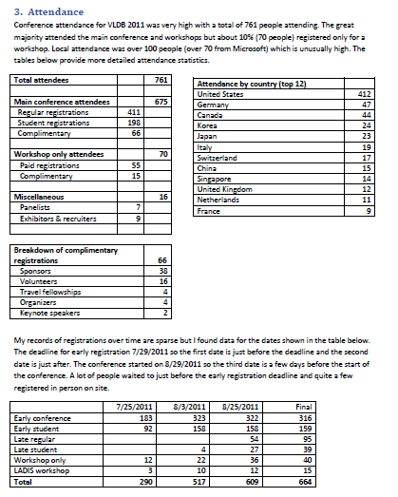

Singapore 2010

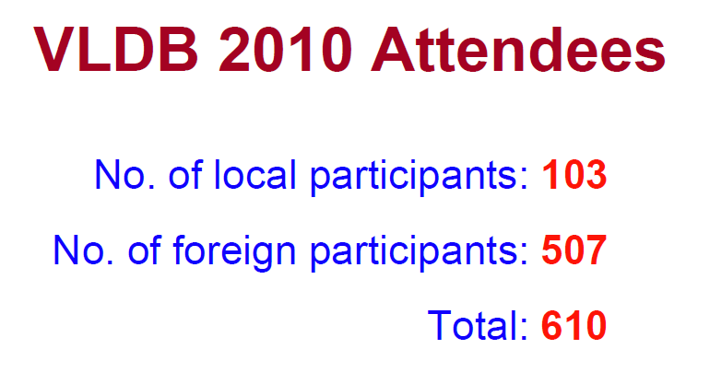

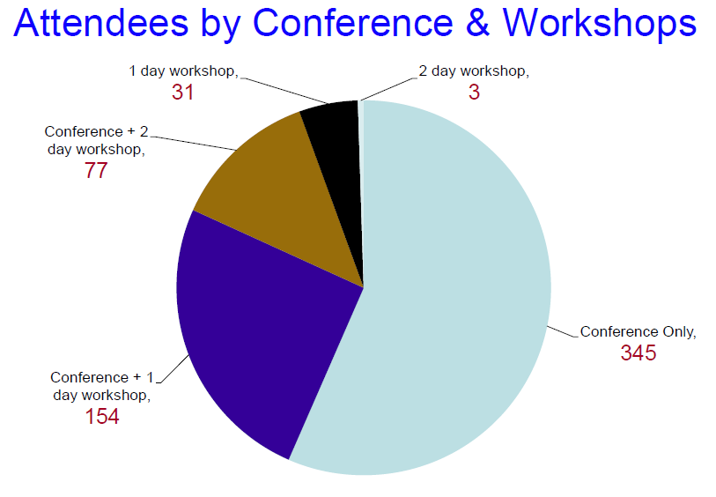

Lyon 2009

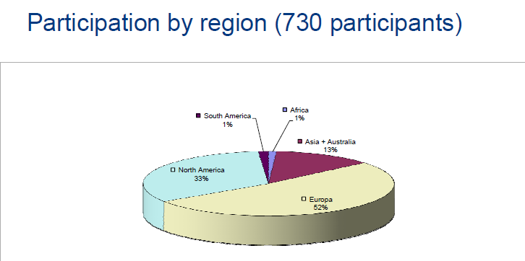

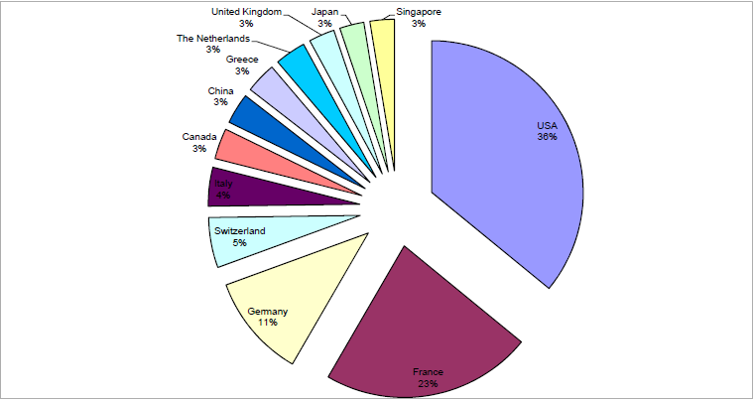

Auckland 2008

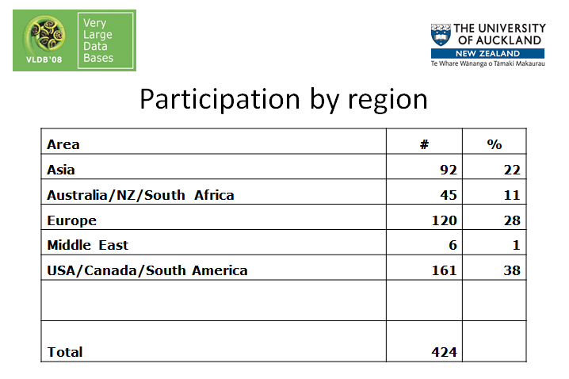
Appendix V

Registration fees for recent conferences

Istanbul 2012

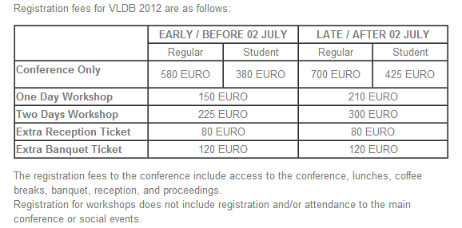

Seattle 2011

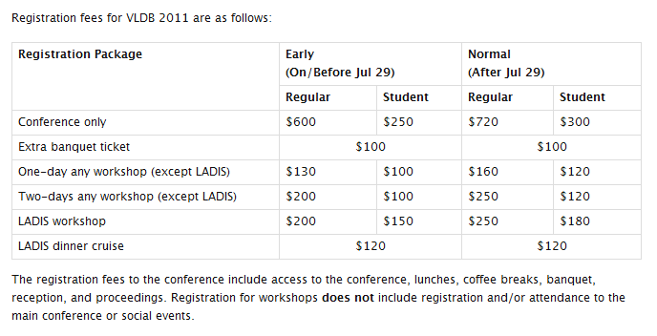

Singapore 2010

(in Singapore $)

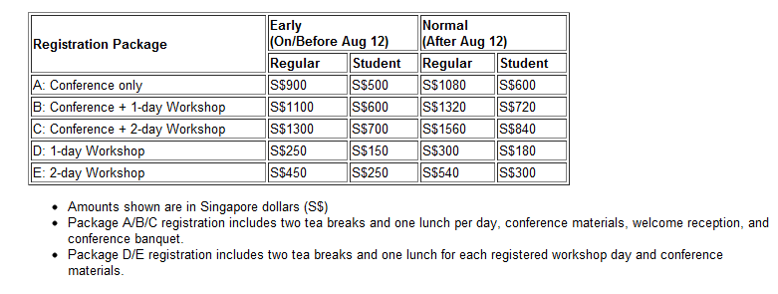

Lyon 2009

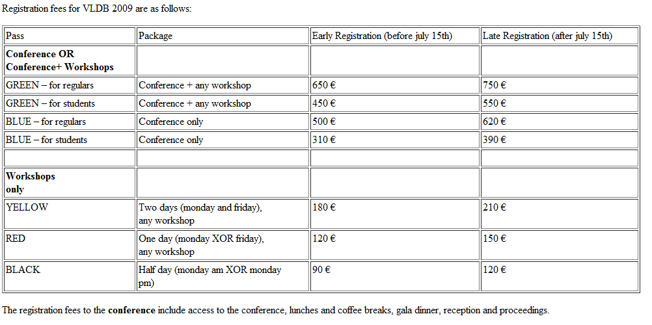

For information on PVLDB, see http://vldb.org/pvldb/

